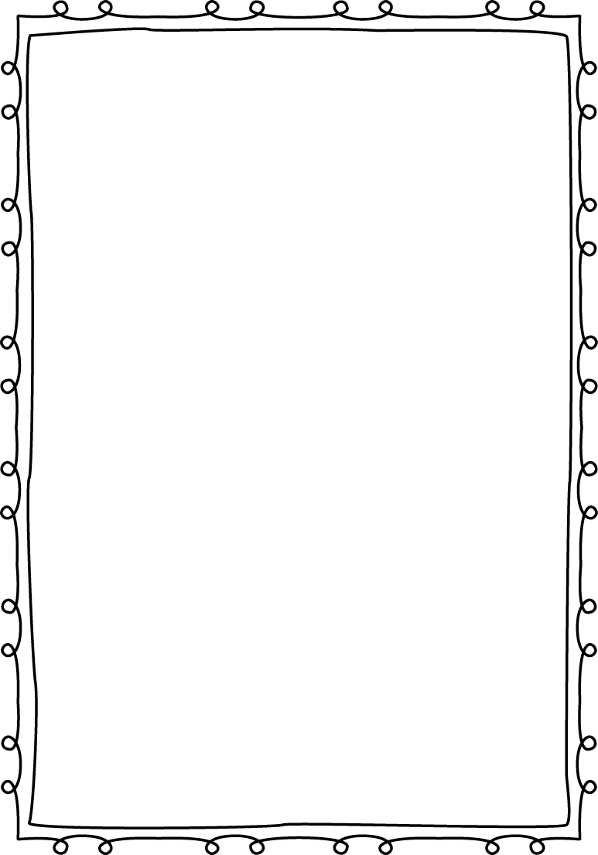
Read, Rock, and Roll!

2019 - 2020 School Year

Session I
10:00 – 11:00 AM Wednesday

October 16, 2019
October 23, 2019
October 30, 2019
November 6, 2019
November 13, 2019
November 20, 2019

Session II
10:00 – 11:00 AM Wednesday

January 15, 2020
January 22, 2020
January 29, 2020
February 5, 2020
February 12, 2020
February 19, 2020

Session III
10:00 – 11:00 AM Wednesday

March 4, 2020
March 11, 2020
March 18, 2020
March 25, 2020
April 1, 2020
April 8, 2020

Saint James Preschool Program 7/19 MC

